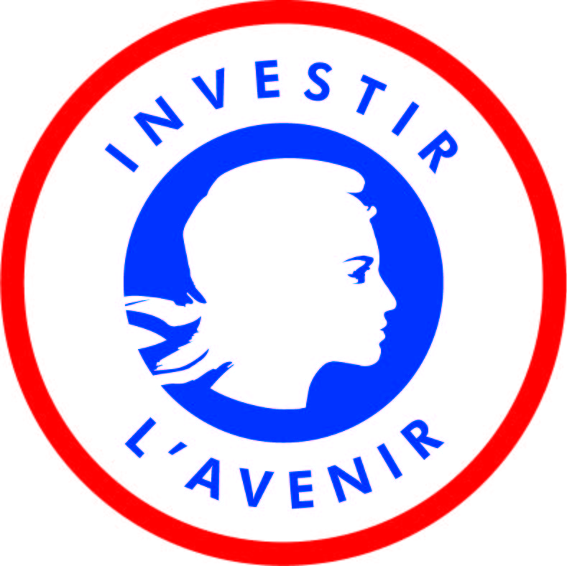

Co-Supervised Doctorates 2019
I-SITE ULNE – Ghent University

Thesis project proposal
to be completed in English

Deadline: May 2, 2019 (23:59 GMT+1)

Please send your application by e-mail to the following address: projects@isite-ulne.fr
(Please copy the promotors and co-promotor(s) on the message.)

Checklist of mandatory documents
(no hard copies are required)
Please send your documents using the following name template:
“[First name]_[name]_[Document name]_CotutellesGand_2019”.

☐ 2-page CV for each promotor and co-promotor
☐ Application form duly completed

For the applicant:
☐ Curriculum Vitae
☐ Cover letter
☐ Copy of passport for students who are not French citizens
☐ Grades obtained during your last 3 years of graduate studies and a description of the degree programme and courses taken for studies completes outside of France. (Official academic transcripts must be provided for each semester of each year.)
☐ Copy of post-secondary diplomas (with translation for degrees that were not obtained from an English- or French-speaking country; at this stage these copies do not have to be legalized)
☐ A letter of support from the potential I-SITE ULNE promotor

I-SITE ULNE Help desk:
stephane.thys@isite-ulne.fr
alexis.boulet@isite-ulne.fr

- PROJECT INFORMATION
Project title (English)
Project acronym
Keywords (between 3 and 6)

  - Identification of the PhD candidate
First name: Last name:
Gender:
Nationality:
Date of birth:
University of origin:
Master’s degree obtained:
Postal address:

Personal telephone:
Work telephone:
Email address:
Signature:

  - Identification of the I-SITE ULNE promotor
First name:
Last name:
Institution:
Faculty/Department:
Research unit:
Do you have an HDR?: ☐ No ☐ Yes, since:
Address:

Tel:
Email address:
Signature¹:

  - Identification of the I-SITE ULNE co-promotor (if applicable)
First name:
Last name:
Institution²:
Faculty/Department:
Research unit:
Do you have an HDR?: ☐ No ☐ Yes, since:
Address:

Tel:
Email address:
Signature³:

  - Identification of the Ghent University promotor
First name:
Last name:
ORCID-ID:
Department:
Department code:
Address:

Telephone:
Email address:
Signature:

  - Identification of the Ghent University co-promotor (if applicable)
First name:
Last name:
ORCID-ID:
Department:
Department code:
Address:

Telephone:
Email address:
Signature³:

- Abstract of the thesis project (250 words maximum)
[To be completed]

PRESENTATION OF THE PROJECT (max. 3 pages excluding the bibliography)
- The doctoral project and methodology, including concrete calendar and selected bibliography
- Added-value of the participation of the (co-)promotors in the project
- Strategy for dissemination and exploitation of the research
[To be completed]

Specific Questions
Expected duration of your stay at Ghent University (Min. 6 months): [______] months
Explain briefly what scientific activities you plan to carry out during your stay at Ghent University (max. 300 words)
[To be completed]

Explain how the involvement of (co-)promotors from Ghent University in the framework of a co-supervised PhD is an added value to the PhD research. (max. 300 words)
[To be completed]

CVs of all promotors and co-promotors (Send each CV as a separate PD file)
Please send the CV of each promotor and co-promotor listed under point 2. The CV should include the 10 most important projects and/or publications of the past 5 years.

Mandatory documents for the applicant (Send each as a separate PDF file)
- Curriculum Vitae (CV)
- Cover letter (one-page minimum)
- Copy of passport for students who are not French citizens
- Grades obtained during your last 3 years of graduate studies and a description of the degree programme and courses taken for studies completes outside of France. (Official academic transcripts must be provided for each semester of each year.)
- Copy of post-secondary diplomas (with translation for degrees that were not obtained from an English- or French-speaking country; at this stage these copies do not have to be legalized)
- A letter of support from the potential I-SITE ULNE promotor

Scanned signatures are acceptable
Université de Lille, Centrale Lille, ENSAIT, ENSCL, IMT Lille-Douai, Sciences Po Lille, ESJ, ENSAPL, ENSAM- Campus de Lille, CNRS, INSERM, INRIA, CHRU de Lille and Institut Pasteur de Lille
Scanned signatures are acceptable

